Purdue Webclock
Guide
Approving, Rejecting and Editing Time
Last Updated 3/19/2019

Contents
Policies & Concepts 3
Employee Responsibilities 3
Supervisor Responsibilities 3
Delegation 3
Resources 3
Support 3
Technical Requirements 4
Notifications 4
Rounding 4
Overtime 4
Holidays, Moving Holidays, Holiday Emergency Work 5
Viewing Employee’s Timesheets in SuccessFactors 5
Accessing Purdue Webclock 5
Review Employee’s Time Pairs 6
Review, Approve, or Reject Time Pairs 6
Edit / Add Time Pairs for Employee 9
Edit Time Pair 9
Add Time Pair 11

Policies & Concepts

Employee Responsibilities
In Purdue Webclock Employees are responsible for:
- Accurately recording time worked using the appropriate access point
- Selecting the appropriate job when recording time (if employee records time for multiple jobs using the webclock)
- Proactively working with their supervisor to resolve issues as needed (i.e. missing time, missed punches, etc.)
- Ensuring that their time is recorded completely and accurately for each pay period by the deadline required by their supervisor
- Remember: The time entered into the system will be considered true and accurate as of the end of an employee’s pay period. It is the employee’s responsibility to review their time often (at least at the end of each shift and at the end of the pay period) to make sure the recorded hours are true and correct; and to review and confirm the accuracy of any changes that a supervisor makes to time entries.

Supervisor Responsibilities
In Purdue Webclock, Supervisors are responsible for:
- Proactively working with their employees to resolve issues as needed (i.e. missing time, missed punches, etc.)
- Reviewing/approving all time pairs for all of their employees by 12:00pm on the Tuesday following the end of each pay period
- Proactively working with their business office to update employee work schedules and report costing exceptions for their employees’ time worked
- The Purdue Webclock inherits SAP Org Structure. Supervisors are only responsible for and able to access/edit time pairs of employees of whom which they are the supervisor of record in SAP.
- Remember: The time entered into the system will be considered true and accurate as of the end of an employee’s pay period. It is the employee’s responsibility to review their time often (at least at the end of each shift and at the end of the pay period) to make sure the recorded hours are true and correct; and to review and confirm the accuracy of any changes that a supervisor makes to time entries.

Delegation
Delegation is not available in the webclock. Delegations set in SuccessFactors are not inherited by the webclock.
Approved time pairs will be transferred to SuccessFactors; in the event that a supervisor does not approve, unapproved time pairs will also be transferred. The time pairs remain viewable and editable by the supervisor even after being transferred. The supervisor should review and approve the time pairs at their earliest convenience.

Resources
The most current versions of all timekeeping resources for Employees and Supervisors can be found on the Payroll’s SuccessFactors Timekeeping website. https://www.purdue.edu/timehelp

Support
Please contact your supervisor with any Webclock-related questions or concerns.

Technical Requirements
Supported browsers: Chrome, Safari, Edge, Firefox, Internet Explorer
Mobile access: Device must have a web browser and a WIFI or data connection

Notifications
The WebClock provides a Notification Center for Employees (one Notification Center per position held).  Employees receive notifications when a time record is changed (edited/added), time pairs are approved, time pairs are rejected, and when punches are missed.  Supervisors do not receive notifications. |  |  | 

Rounding
- The Webclock assesses the total time duration of the time pair to determine how to round.
  - First, Webclock determines the total time duration for the time pair. Examples: 4 hours 7 minutes, 8 hours 5 minutes, etc.
  - If the total time duration does not correspond to a number of minutes representing a tenth of an hour (see Minutes to Tenths table below), Webclock will round the IN punch down (in the employee’s favor) so that the total time duration matches a tenth of an hour.
  Minutes Translated to Tenths
  0:06 = .1
  0:12 = .2
  0:18 = .3
  0:24 = .4
  0:30 = .5
  0:36 = .6
  0:42 = .7
  0:48 = .8
  0:54 = .9
  1:00 = 1.0
  Punch Type | Punch Time | Duration | Rounded Punch Time | Final Duration
  IN | 7:15 AM | 4 hours,  47 minutes | 7:14 AM | 4 hours, 48 minutes
  OUT | 12:02 PM | 4 hours,  47 minutes | N/A | 4 hours, 48 minutes
  IN | 1:54 PM | 2 hours,  50 minutes | 1:50 PM | 2 hours, 54 minutes
  OUT | 4:44 PM | 2 hours,  50 minutes | N/A | 2 hours, 54 minutes
  IN | 6:03 PM | 3 hours, 6 minutes | N/A | 3 hours, 6 minutes
  OUT | 9:09 PM | 3 hours, 6 minutes | N/A | 3 hours, 6 minutes

Overtime
The Purdue Webclock adheres to the University policy regarding overtime. When a full time employee works over 40 hours in a workweek, the time will be designated as overtime when it transfers to SuccessFactors for payroll. “Hours worked” in a work week will consist only of hours actually worked. (Exception: Worker’s Compensation, University Holidays).

Overtime for employees with multiple positions will be calculated when the time recorded using the webclock is moved to SuccessFactors prior to Payroll running. Overtime will be charged to each position based on the ratio of hours worked across the employee’s positions for that week.

Overtime is viewable by the supervisor and employees on the Timesheet accessible via SuccessFactors. (Found on the employee’s record in the My Info section – click the Timesheet tile)

Holidays, Moving Holidays, Holiday Emergency Work
Holidays
Holiday premiums are auto-calculated when time recorded using the webclock is moved to SuccessFactors to be paid.

Moving Holidays
Moving Holidays takes place within SuccessFactors Time Off tile (not within the Webclock). Individuals whose work schedule does not include a given University Holiday can use the time off feature within SuccessFactors to request Holiday on any day during the week (Monday through Sunday; Sunday through Saturday (dispatchers only)) of the holiday. Exception: Police and Fire may request Holiday leave at any time throughout the year.

Unplanned Work on a Holiday or During an Emergency
Per University policy, when an employee works during an emergency or unscheduled holiday work, they qualify for their hours to be paid at time and a half. In the event that an essential personnel are required to work during an emergency or unscheduled on a holiday, the employee or their supervisor must enter the time on the employee’s timesheet in Employee Central Time (ECT) using time type Campus Service Disruption in addition to recording time in the webclock. For details on this process, see QRG: Campus Service Disruption found at www.purdue.edu/timehelp)

Viewing Employee’s Timesheets in SuccessFactors
Supervisors of staff who utilize the Webclock may wish to view their employee’s timesheets in successfactors. Time Pairs appear on the SuccessFactors timesheet approximately 20 minutes after they have been approved by the supervisor.
Supervisors may wish to reviewing the timesheet in SuccessFactors for the following reasons:
- Allows review of previously approved time pairs (they are removed from the supervisor’s Webclock queue after approval)
- Displays total hours
- Displays Time and Time Off data in one view
Note: It is only necessary to approve time pairs in the WebClock itself, approval of the SuccessFactors Time Sheet is not required or recommended.
 |  |  | Accessing Purdue Webclock
The Purdue webclock can be accessed via four different access points. Your department will designate a best practice as far as which access method you should utilize.
OneCampus Portal  Employee Launchpad  SuccessFactors | OneCampus Portal  Timekeeping System  Webclock |  |  | Web Browser | Kiosk
Navigate to the One Campus Employee Portal (one.purdue.edu)  Click the Employee Launchpad tile.  Log in using your BoilerKey.  On the homepage, click the WebClock tile. | Navigate to the One Campus Employee Portal (one.purdue.edu)  Click the Timekeeping System tile.  Log in using your BoilerKey. |  |  | On your computer or mobile device’s web browser, navigate to webclock.purdue.edu  This link can be bookmarked or saved as a favorite for convenience.  Log in using Purdue User ID and BoilerKey passphrase. | Kiosk are iPads designated for Webclock use, equipped with a card reader and typically mounted to a wall.  At a kiosk, swipe your Purdue ID Card through the card reader.

Review Employee’s Time Pairs
For each pay period, supervisors should approve each time pair for each employee prior to 12:00pm Tuesday the week following the end of the pay period.

All time recorded for the previous pay period by the employee as of 12:00pm on the Tuesday following the end of the pay period will be paid, as long as the supervisor has not declined the time. Supervisor approval is not required for the time to be paid, but the supervisor must review, edit, and approve the time pairs at their earliest convenience.

Time recorded for the previous pay period by the employee after the 12:00pm Tuesday deadline must be approved by the supervisor in order for it to be paid. The supervisor must approve prior to when payroll locks to begin the payment process. Payroll lock occurs at variable times between 12:00pm and 5:00pm on Tuesday.

If an employee submits changes to their recorded time after approval by the supervisor, the supervisor must review and approve the revised time in order for it to be paid. Changes to previously approved time/timesheets will never be paid unless approved by the supervisor.

Supervisors have access to run the report SuccessFactors Time Details Report for Managers at any time using the SuccessFactors Report Center. This report provides an overview of Time and Time Off entries for each employee. Note: Only approved time pairs will appear in the report.

Review, Approve, or Reject Time Pairs
Optional: Use the Position filter to view a specific group  Note: Supervisors of individuals with multiple positions will only see time recorded for the position(s) that they supervise. |  | 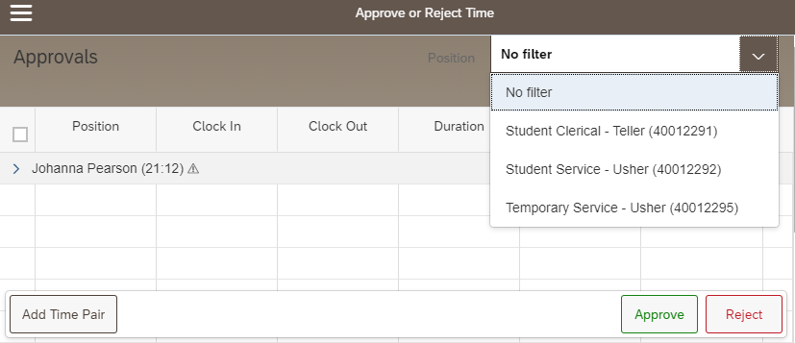
Click an individual’s name to view their time pairs  Exceptions are indicated by an alert icon next to the individual’s name ()  Color Indicators  - Orange  - Time pair was added or edited (by employee or supervisor)  - Type column reads Correction or Manual  - Red  - Missed punch  - No data in clock in or clock out, alert icon displayed  - Type column reads: Clock  - Blue  - Location Services were not enabled by the user |  | 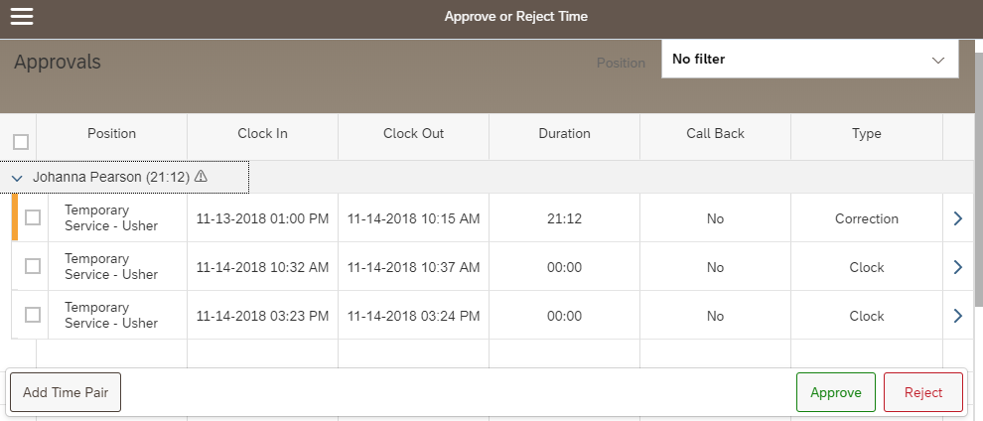

Click the arrow at the end of each line to view details and edits and/or reason for edit (if applicable) | 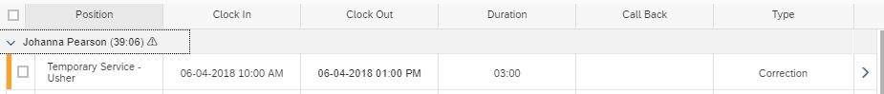
Click Map to view clock in and clock out locations  - Employees are instructed to enable location services if using a mobile device (phone or tablet).  - The precision of location services on desktop and laptop computers will vary. | 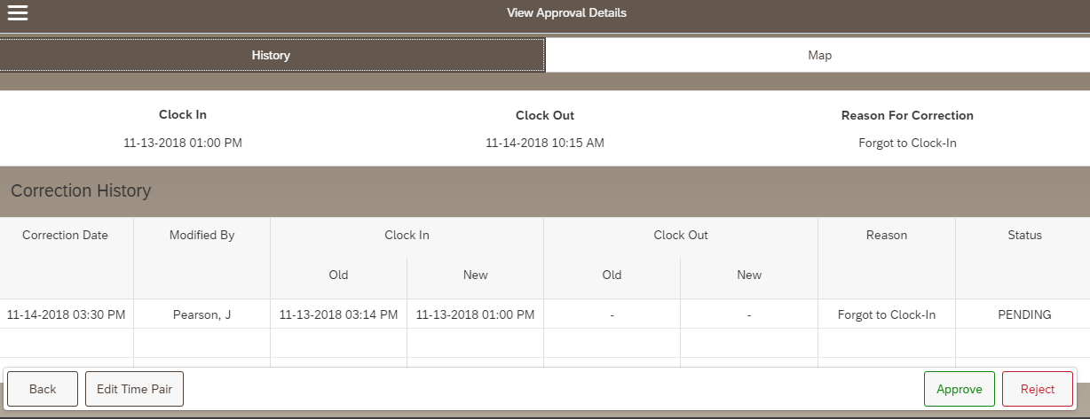
Clock in (green pin) and clock out (red pin) locations are displayed | 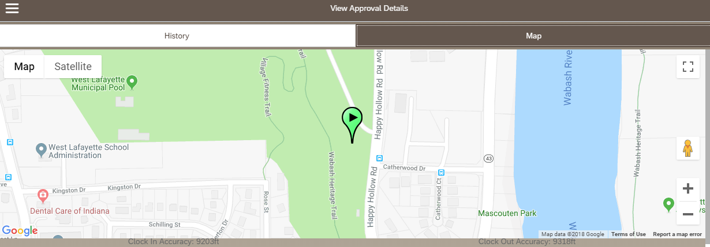
Approving Time Pairs  - Mark the box next to each time pair to be approved  -or-  - Click Select All.  This selects all time pairs for all employees whose records are expanded. See step 4 to select all without expanding records.  - After completing Steps 1 or 2, Click Approve  - Another option is to use the Approval All or Reject All buttons. This action will apply to all time pairs for all employees, even if the record is not expanded. | 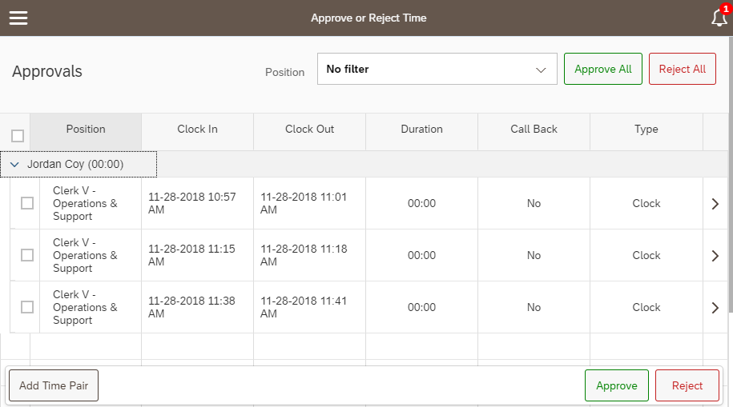  4  3  2  1
Employees can edit time pairs after the supervisor has approved. The pair will re-appear in the supervisor’s queue as PENDING. Employees are instructed to notify their supervisor if they edit after they believe their supervisor has completed their final edits for the pay period.

To view/edit an employee’s time after approving it, access their Timesheet in SuccessFactors. (Log in to SuccessFactors, search for employee’s name, click Timesheet tile)

If an approved time pair needs to be edited, the edit must be completed by the employee.
Rejecting Time Pairs
Mark the box next to each time pair to be rejected or click Select All.
Click Reject.
Employees receive a notification in their Notification Center if time pairs are rejected and the time pair will be marked DECLINED in their History. If applicable, the employee must submit a new time pair for approval to replace the rejected pair(s).

Edit / Add Time Pairs for Employee
In the instance that an employee is unavailable to edit their time records, a supervisor may edit them on their behalf. Employees receive a notification in their Notification Center that their time record has been edited.
If a correction needed is to time pairs in the Webclock that the supervisor has previously approved (and thus have been removed from their view), AND the employee is unavailable to make the correction, the supervisor should make the correction on the timesheet in SuccessFactors. This should be treated as a last resort due to potential errors, time collisions, and loss of the employee’s ability to review the time entry. See the Positive Duration Time Entry materials found at www.purdue.edu/timehelp for instructions on entering time on the timesheet in SuccessFactors.

Edit Time Pair
Employees or Supervisors can edit time pairs at any time within the current or previous two pay periods. Newly added pairs will be added to the supervisor’s queue as PENDING. Employees are instructed to notify their supervisor if they edit or add a time pair after they suspect the supervisor has completed their final review prior to Payroll running.
Optional: Use the Position filter to view a specific group

Click an individual’s name to view their time pairs
Click the arrow at the end of the line to be edited.

Note: Supervisors can only edit time pairs with missed punches after the individual has been clocked in for 12 hours. If an edit is needed sooner, the employee must complete the edit.
Click or tap Edit Time Pair | 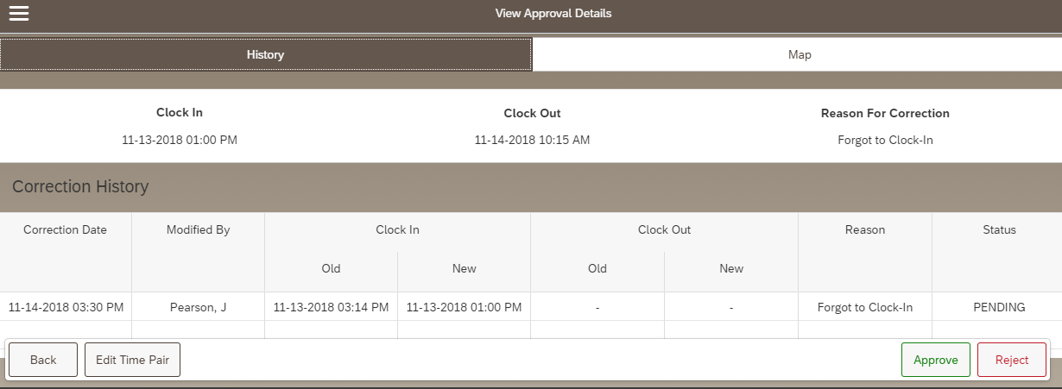
- Use the Reason drop-down menu to select the reason for the edit.  - Tap or click the calendar icon on the appropriate line to edit the Clock In or Clock Out.  - Use the calendar and/or time sliders to indicate the new date or time.  - Click OK  - Click Submit Changes | 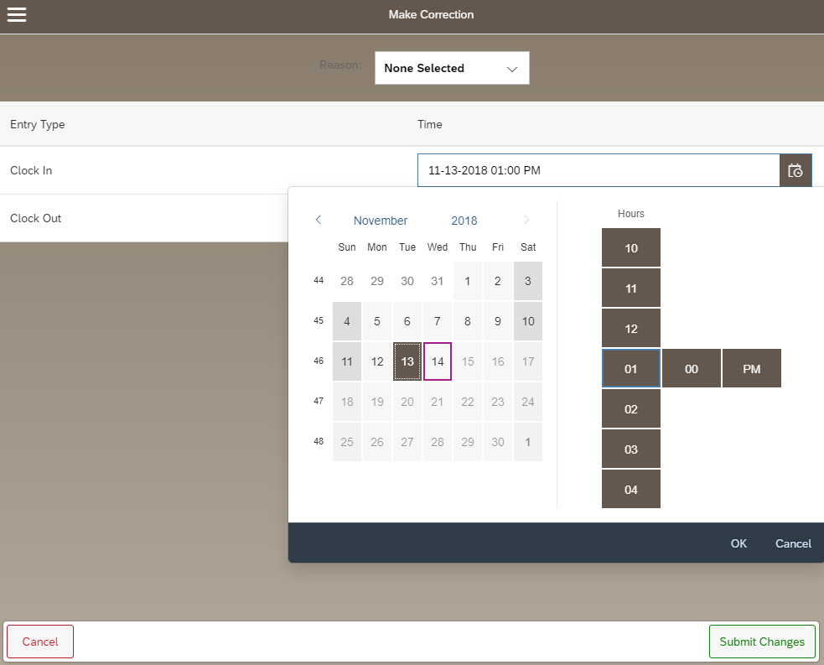  5  4  3  2  1
The Approval Details screen is displayed.  This time pair can be Approved on this screen, or click Back to return to your approval queue. | 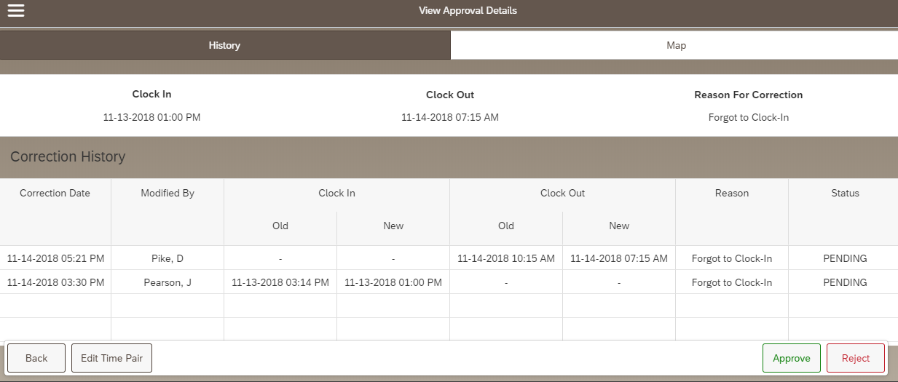

Add Time Pair
Employees or Supervisors can add time pairs at any time within the current or previous pay period. Newly added pairs will in the supervisor’s queue as PENDING. Employees are instructed to notify their supervisor if they edit or add a time pair after they suspect the supervisor has completed their final review prior to Payroll running.
Optional: Use the Position filter to view a specific group
Click an individual’s name to view their time pairs.

Click Add Time Pair to add a new time pair.

IMPORTANT  Use the drop-down menus to select:  - Employee  - Position | 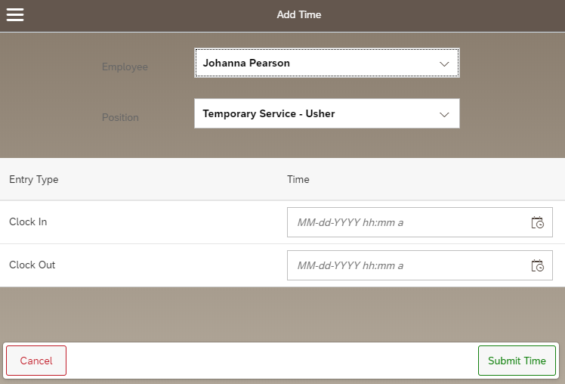
- Tap or click the calendar icon on the appropriate line to edit the Clock In and Clock Out date and time.  - Use the time sliders to indicate the new date and the “In” time and “Out” time.  - Click OK  - Click Submit Time | 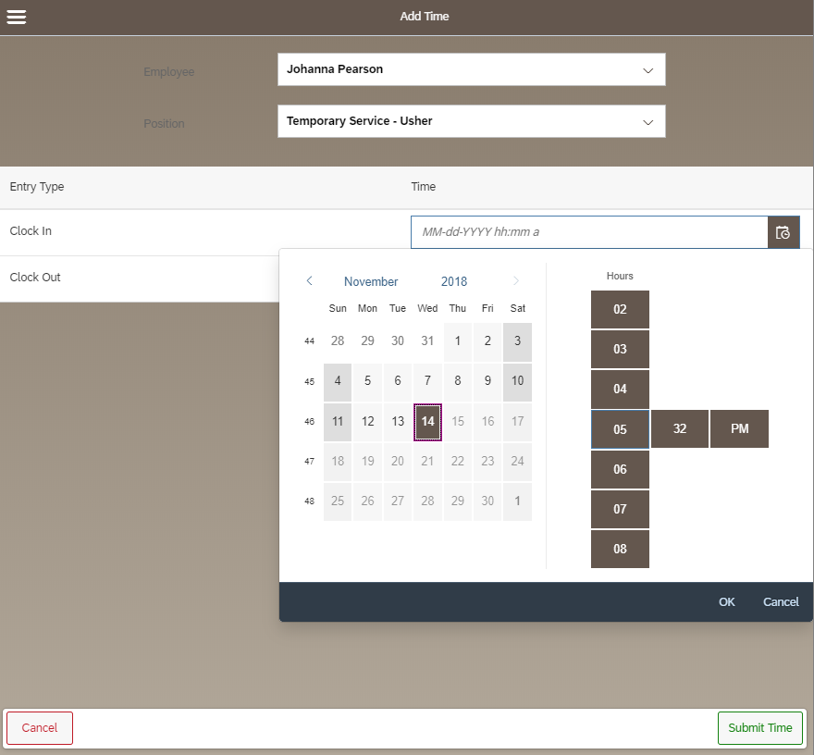  4  3  2  1
The time is now visible in the supervisor’s queue in PENDING status (awaiting approval).

